###### WATER

INTRODUCTION

Water is the nature’s most wonderful, abundant and useful compound. Of the many essential elements for the existence of human beings, animals and plants, water is rated to be of greatest importance. Without food human being can survive for a number of days, but water is such an essential thing without it one cannot survive. Water is not only essential for the lives of animals and plants but also occupies unique position in industries. Probably its most important use as an engineering material is in the ‘steam generation’. Water is also used as a coolant, in power, and chemical plants. In addition to it, water can also be used in the production of steel, rayon, paper, textiles, chemicals, irrigation, drinking firefighting, etc.

###### OCCURRENCE:

Water is the only substance that occurs at ordinary temperatures in all three states of matter: Solid, Liquid and Gas. As a solid ice, it forms glaciers, frozen lakes and rivers, snow, frost. It is liquid as rain and dew, and it covers three- quarters of the earth’s surface in swamps, lakes, rivers and oceans. Water also occurs in the soil and beneath the earth’s surface as a vast groundwater reservoir. As gas, or water vapour, it occurs as fog, steam and clouds.

###### CHARACTERISTICS OF WATER

As per the suggestion given by World Health Organization (WHO) and by Indian Council of Medical Research (ICMR), the following are the important characteristics of potable water.

1. It should be clear, colourless and odourless.
2. It should be free from harmful bacteria and suspended impurities.
3. It should be free from dissolved gases like CO2, H2S, NH3, etc., and poisonous minerals like lead, arsenic, manganese, etc.,
4. Hardness should be less than 120 ppm.
5. Chloride ion content should be less than 250 ppm.
6. Fluoride ion content should be less than 1.5 ppm.
7. Total Dissolved Solids (TDS) content should be less than 50 ppm.
8. pH of the potable water should be 6.5 – 8.5.

###### CHEMICAL CHARACTERISTICS OF WATER

The most important chemical characteristics of water are its acidity, alkalinity, hardness and corrosiveness. Chemical impurities can be either natural, man-made (Industrial) or be deployed in raw water sources by enemy forces. Some chemical impurities cause water to behave as either an acid or a base. Since either condition has an important bearing on the water treatment process, the pH value must be determined. Generally the pH influences the corrosiveness of the water, chemical dosages necessary for proper disinfection and the ability to detect contaminants.

###### HARDNESS

Hardness of water is that characteristic property which prevents the lathering of soap. It is caused by the soluble salts of calcium, magnesium, iron, manganese and other heavy metal ions. The degree of hardness depends on the type and amount of impurities present in the water. Hardness also depends on the amount of carbon-di-oxide in solution. Carbon-di-oxide influences the solubility of the impurities that cause hardness.

When a sample of hard water treated with soap it does not produce lather. It forms a white precipitate or SCUM. Soap is sodium salt of higher fatty acid like oleic or palmitic or stearic acid.

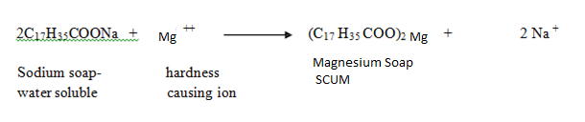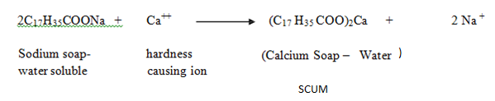

**Disadvantage of hardness**

1. **Domestic usage**

|  |  |
| --- | --- |
| Washing | It causes wastage of soap and forms precipitate which stick to cloth giving patch or spot. |
| Cooking | Fuel wastage |
| Washing | It causes wastage of soap and forms precipitate which stick to cloth giving patch |
| Drinking | It imparts unpleasant taste to water also effects on digestive and urinary system |

1. **Disadvantages to Industry**

|  |  |
| --- | --- |
| Textile Industry | It causes wastage of soap and forms precipitate which stick to cloth giving patch or spot and uneven colour of cloth. |
|  |  |
| Sugar Industry | Water containing sulphates, nitrates interfere in crystallization of sugar. Ans sugar so produced may undergo decomposition during storage. |
|  |  |
| Dyeing industry | It causes imperfect shades and uneven spots on fabric |
|  |  |
| Paper Industry | It causes pigmentation on paper due to presence of heavy metal ions and transition metals. |
|  |  |
| Concrete Industry | It causes slowdown in hydration of cement and hence final strength of cement reduces. |
|  |  |
| Food industry | It causes formation of certain undesirable products and thereby reducing the shelf life. |
|  |  |
| Laundary | Wastage of soaps and water |

**III) Boiler Trouble**

|  |  |
| --- | --- |
| Sludge Formation | Sludge is soft loose and slimy precipitate formed in boiler. It can be easily removed. It chokes the pipe by getting accumulated at corners and turn. |
|  |  |
| Scale Formation | Scales are hard deposits which stick firmly to the inner surface of boiler. It is difficult to remove even wit the help of hammer and chisel. It causes fuel wastage, lowering safety and explosion of boilers. |

**Caustic Embrittlement**

**‘**Caustic embrittlement is a type of boiler corrosion which makes boiler material brittle’. This is caused by highly alkaline water in boiler in the boiler. During lime soda process free Na2CO3 is usually present in small proportion which decomposed to NaOH under pressure. The water containing NaOH flows into minute hair cracks by capillary action where water evaporates and concentration of NaOH increases progressively. This caustic soda attacks the metals thereby dissolving the iron in the form of sodium ferroate. This causes embrittlement of boiler parts.

Na2CO3 + H2O ------> 2 NaOH + CO2

2 NaOH + Fe ------> Na2FeO2 + H2

Sodium hypoferrite

6 Na2FeO2 + 6 H2O + O2 ------> 12 NaOH + 2 Fe3O4 (Black rust)

###### Caustic embrittlement can be avoided by

1. By using sodium phosphate as a softening agent instead of sodium carbonate.
2. By adding tannin or lignin to the boiler water, since these substances block the hair cracks, thereby preventing the infiltration of the caustic soda solution in to these.
3. By adding sodium sulphate to boiler water: Sodium sulphate blocks the hair cracks preventing the infiltration of caustic soda solution in to these. It has been observed that caustic cracking can be prevented.

###### SOFT WATER

Soft water produces lather readily when treated with soap solution. This is due to the absence of salts of metal ions.

How to detect hardness?

When the water is treated with soap solution, if it prevents lathering and forms white scum, the water contains hardness. Water containing hardness gives wine red colour with Eriochrome Black –T indicator.

The total water hardness (including both Ca2+ and Mg2+ ions) is read as parts per million (ppm) or weight / volume (mg/L) of Calcium Carbonate (CaCO3) in the water. Although water hardness usually measures only the total concentrations of calcium and magnesium (the two most prevalent, divalent metal ions), iron, aluminum and manganese may also be present at elevated levels in some geographical locations. The predominant source of magnesium is dolomite (CaMg (CO3)2).

###### TYPES OF HARDNESS

Depending upon the types of dissolved salts present in water, hardness of water can be classified into two types:

Temporary Hardness

Permanent Hardness

###### Temporary Hardness (or) Carbonate Hardness (CH) (or) Alkaline Hardness

Temporary hardness is caused by carbonate, bicarbonate and hydroxide of calcium and magnesium ions in the water. It can be removed by boiling water or by the addition of lime (Ca(OH)2)

Boiling promotes the formation of carbonate from the bicarbonate and precipitates calcium carbonate out of solution, leaving water that is softer upon coving.

Ca (HCO3)2→ CaCO3 ↓+ H2O + CO2

###### Permanent Hardness (or) Non – Carbonate Hardness (NCH) (or) Non – alkaline Hardness

Permanent hardness is hardness (mineral content) that cannot be removed by boiling. It is usually caused by the presence of sulphates, chlorides, nitrates of calcium and magnesium and other metal ions which become more soluble on boiling. Despite the name, permanent hardness can be removed using water – softener or ion-exchange column, where the calcium and magnesium ions are exchanged with the sodium ions in the column. It can be removed by

Lime – Soda process

Zeolite process

###### Total Hardness: The sum of temporary hardness and permanent hardness is called total hardness.

**Expression of hardness in terms of equivalents of CaCO3**

The concentrations of hardness producing salts are usually expressed in terms of equivalent amount of CaCO3. CaCO3 is chosen as a standard because, Its molecular weight (100) and equivalent weight (50) is a whole number, so the Calculations in water analysis can be simplified.

1. If the concentration of hardness producing salt is x mgs/lit. then

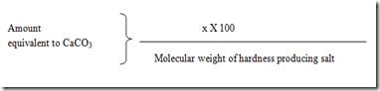

###### UNITS OF HARDNESS

1. **Parts per million (ppm):**It is defined as the number of parts of CaCO3 equivalent hardness per 106 parts of water.

###### Milligrams per litre (mg/lit)

It is defined as the number of milligrams of CaCO3 equivalent hardness per 1 litre of water.

###### Clarke’s degree (oCl)

It is defined as the number of parts of CaCO3 equivalent hardness per 70,000 parts of water.

###### French degree (oFr)

It is defined as the number of parts of CaCO3 equivalent hardness per 105 parts of water.

###### Relationship between various units

1ppm = 1 mg/lit = 0.10 Fr = 0.070 Cl

###### ESTIMATION OF TOTAL HARDNESS OF WATER BY EDTA METHOD

The hardness of water is estimated by EDTA method using Eriochrome Black –T [EBT].

###### Principle:

The calcium and other metal ions present in the water is capable of forming complex with Indicator EBT and also with the EDTA in the pH range 8- 10.To keep the solution at this pH range , a buffer [ mixture of ammonium chloride and ammonium hydroxide ] is used . The complex between EDTA and indicator is more stable that of between the metal ion and indicator.

Hence during the titration wine red complex of Metal EBT is broken by more stable metal EDTA. The indicator EBT is set free which is blue in colour, hence during end point colour changes from wine red to blue.

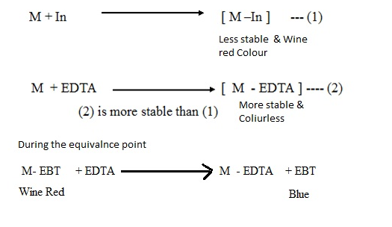

**PREPARATION OF SOLUTIONS:**

* 1. **Standard hard water:** 1 gm of dry CaCO3 is dissolved in minimum quantity of HCl and evaporate the solution to dryness on a water bath, and then diluted to 1 lit with water. Each ml of this solution then contains 1 mg of CaCO3 hardness.
  2. **EDTA solution:** 4 gm of EDTA crystals + 0.1 gm MgCl2 in 1litre.
  3. **Indicator:** 0.5 gm of EBT in100 ml of alcohol.
  4. **Buffer solution:** 67.5 gm NH4Cl + 570 ml of Con. Ammonia solution diluted with distilled water to 1 lit.

**Determination of Total Hardness, Temporary Hardness and Permanent Hardness:**

Concentration of standard hard water = 1000 ppm = 1000 mg /L

1000 ml of standard hard water sample = 1000 mg of CaCO3

Therefore 1 ml of standard hard water sample = 1 mg of CaCO3

**Part: I Standardization of EDTA solution:**

50 ml of standard hard water + 1/5 T.T. of buffer pH-10 + few drops of EBT indicator-🡪 wine red colour

Titrate this with EDTA solution,

End point: wine red to blue colour

Let V1 ml of EDTA is required for the titration.

50 ml of standard hard water = V1 ml of EDTA solution

50 x 1mg of CaCO3 hardness = V1 ml of EDTA

Therefore, 1 ml of EDTA = 50 /V1 mg of CaCO3

**Part –II: Determination of Total Hardness**

50 ml water sample + 1/5 T.T. of buffer pH-10 + few drops of EBT indicator-🡪 wine red colour

Titrate this with EDTA solution,

End point: wine red to blue colour.

Let V2 ml of EDTA is required for the titration.

50 ml of hardness of water sample = v2 ml of EDTA

= V2 x 50 /V1 mg of CaCO3

Total Hardness = V2 /V1 x1000 mg/L or ppm

**Part: III Determination of Permanent Hardness**

50 ml water sample boil off for 10 minute and filter + 1/5 T.T. of buffer pH-10 + few drops of EBT indicator-🡪 wine red colour. Titrate this with EDTA solution,

End point: wine red to blue colour

Let V3 ml of EDTA is required for the titration.

50 ml of boiled water sample hardness = V3 ml of EDTA

= V3 x 50 /V1 mg of CaCO3

Permanent Hardness = V3 / V1 x 1000 mg of CaCO3 /lit or PPM

**Temporary Hardness:**

Temporary Hardness = Total Hardness - Permanent Hardness

###### 3.1 Advantages of EDTA method:

This method is definitely preferable to the other methods, because of the

1. Larger accuracy; (ii) Convenience; (iii) Rapid procedure

###### SOFTENING METHODS

Water used for industrial purposes (such as for steam generation) should be sufficiently pure. It should, therefore, be freed from hardness- producing salts before it is being put to use. The process of removing hardness-producing salts from water is known as softening of water. Water softening is achieved either by adding chemicals that form insoluble precipitates or by ion exchange. On a small scale, chemicals used for softening include ammonia, borax, calcium hydroxide (slaked lime), or trisodium phosphate, usually in conjunction with sodium carbonate (soda ash). In industry three methods are mainly employed for softening of water.

1. **Lime soda method**
2. **Zeolite-Permutit method**
3. **Ion Exchange method**

###### Lime soda process:

Lime is added either as calcium hydroxide or calcium oxide, and soda is added as sodium carbonate. The substances form hardness in water and the reactions of lime and soda can be written as follows.

|  |  |  |  |
| --- | --- | --- | --- |
| **Name of Impurities** | **Reaction with Lime** | **Reaction With Soda** | **L & S Requirement** |
|  |  |  |  |
| **1.Temp Ca** | Ca(OH)2 +Ca(HCO3)2 --------> 2CaCO3 + 2H2O | No Reaction | L |
|  |  |  |  |
| **2. Temp Mg** | Mg(HCO3)2 + 2 Ca(OH)2 --------> Mg(OH)2 + 2CaCO3 + 2 H20 | No Reaction | 2L |
|  |  |  |  |
|  |  |  |  |
| **3.Perm Mg** | Ca(OH)2 +MgSO4 -------->**CaSO4**+ Mg(OH)2 | **CaSO4** +Na2CO3 -------->CaCO3+ Na2SO4 | L+ S |
|  |  |  |  |
| **4.Perm Al** | 3Ca(OH)2 +Al2(SO4)3 --------> 2Al(OH)3+ **3 CaSO4** | **CaSO4** +Na2CO3 -------->CaCO3+ Na2SO4 | L + S |
|  |  |  |  |
| **5.Perm Fe** | Ca(OH)2 +Fe(SO4) -------->Fe(OH)2+ **CaSO4** | **CaSO4** +Na2CO3 -------->CaCO3+ Na2SO4 | L + S |
|  |  |  |  |
| 6. CO2 | CO2 + Ca(OH)2 --------> 2 CaCO3 + 2H2O | No Reaction | L |
|  |  |  |  |
| 7. NaHCO3 | 2NaHCO3 + Ca(OH)2 --------> CaCO3 + **Na2CO3** +2H20 | No Reaction | L - S |
|  |  |  |  |
| 8. NaAlO2 | NaAlO2 + H2O --------> Al(OH)3 + **NaOH** |  | **(-L)** eq to Ca(OH)2 |
|  |  |  |  |

**Lime soda process:**

In lime-soda process, hard water is treated with lime (CaO or Ca (OH)2) firstly, after that with soda. In this process, the hardness is removed by sedimentation as calcium carbonate or magnesium hydroxide. The process can be performed in two ways depending on temperature of lime soda reaction.

1. Cold lime soda process
2. Hot lime soda process

**Cold Lime Soda Process:**

In this process calculate amount of quantities of lime and soda are mixed with water at room temperature. The precipitates formed are finely divided and therefore do not settle down easily and cannot be filtered easily. Thus it is essentially to add small amount of coagulant like alum.

NaAlO2+2H2O → NaOH + Al(OH)3

Eq. to Co-agulant

Lime

Method:

The cold lime soda softener consists of inner vertical chamber and outer vertical chamber. The inner chamber is fitted with rotating In this method, the soluble calcium and magnesium salts in water are chemically converted into insoluble compounds, by adding calculated amounts of lime [Ca(OH)2] and soda [Na2CO3]. Calcium carbonate [CaCO3] and magnesium hydroxide [Mg(OH)2] are precipitated and removed. Coagulant is necessary because at room temperature precipitate is finally divided. But do not settle easily & cannot easily filtered.Mechanical stirrer is used to increase mixing & rate of precipitate formation. The residual hardness of this method is 55-60 ppm.

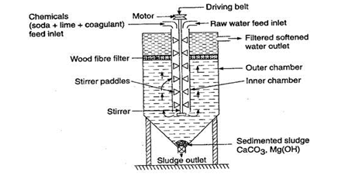

Hot-Lime soda:

Hot process softening is usually carried out under pressure at temperatures of 200-240°F (85-110°C). At the operating temperature, hot process softening reactions go essentially to completion. The solubility of calcium, magnesium, and silica are reduced by increased temperature. Therefore, they are more effectively removed by warm lime softening than by cold lime softening. This treatment method involves the same reactions described above, except that raw water CO2 is vented and does not participate in the lime reaction.

Due to hot condition-

i) Reactions take place faster.

ii) No need of coagulant

iii) Dissolved gases are expelled out at high temperature

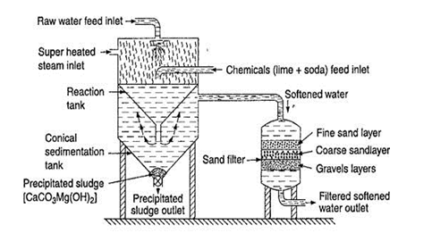

**Advantages:-** i) It is more economical

ii) Less amount of coagulant is required.

iii) Also Fe, Mn & minerals are reduced.

iv) Highly acidic /alkaline water can be treted

**Disadvantages:-**

i) The hardness is 50-60 ppm by cold process & about 15-30 ppm by hot process

ii) Careful operation & skilled supervision are required.

iii) Disposal of large quantity of sludge formed during process is a problem.

###### Zeolite- Permutit Method:

###### Zeolite is micro-porous mineral which is used as catalyst for many industrial purposes such as water purification and air purification. The zeolites are hydrated alumino silicates and general composition Na2O.Al2O3. X SiO2. Y H2O. Zeolites are two types natural and synthetic or artificial. The natural zeolite that is used for water softening is gluconites or greensand. Permutit is the synthetic zeolite that is most used in water softening. These are used as ion exchanger and for odor removal in water softener. Permutit are more porous, glassy and have higher softening capacity than greensand. Zeolites are soft to moderately hard, light in density, insoluble in water but can act as base exchangers in contact with water containing cations. Hence these can remove Ca+2 and Mg+2 ions from water.

###### Discuss zeolite process with the help of diagram, chemical reactions and state its advantages and limitations.

###### Process:

###### Zeolite software is made up of a cylinder in which there is a bed of zeolite hard water is circulated through bed of zeolite at a specific rate. The hardness producing iron like Ca 2 + and Mg 2 + ion and other hardness producing ions are retain by zeolite forming CaZe and MgZe. The eluted water (outgoing water from the zeolite bed) contains sodium salt and the following reaction take place during sorting process:

###### CaCl2 + Na2Ze ----------> Ca Ze + 2NaCl

###### MgSO4 + Na2Ze ----------> Mg Ze + Na2SO4

###### Regeneration of Zeolite column:

###### During softening of water Ca 2 + and Mg 2 + ions are retained by the zeolite forming CaZe and MgZe i.e. calcium zeolite and magnesium zeolite. Once all the Na2Ze get completely converted to forming CaZe and MgZe. It is said to be exhausted because at this stage zeolite is unable to soften the hard water the supply of soft water is then stop. In order to regenerate the exhausted zeolite, the column is treated with concentrated brine solution the washing calcium chloride and magnesium chloride is discarded and the regenerated zeolite can be used for softening the water.

###### CaZe + 2NaCl ---------->CaCl2 + Na2Ze

###### MgZe + 2NaCl ---------->MgCl2 + Na2Ze

###### Advantages:

###### 1 it removes the hardness almost completely and water of about 10- 15 ppm hardness is produced.

###### 2. The equipment used is compact, occupying a small space.

###### 3 No impurities are precipitated, so there is no danger of sludge formation in the treated water at a later stage

###### 4. The process automatically adjusts itself for variation in hardness of incoming water

###### Disadvantage/ Limitation:

###### The treated water contains more sodium salts than in lime soda process.

###### The method only replaces Ca and Mg ions by Na ons, but leaves all the acidic ions like HCO, and CO3-When such softened water is used in boilers for steam generation it can causes corrosion or causes caustic embrittlement

###### Turbid water and water containing high acidity cannot be treated using zeolite softener.

###### Ion exchange or de-ionization or de-mineralization process:

Ion-exchange resins are insoluble, cross-linked, long chain organic polymers with a microporous structure, and the “functional groups’ attached to the chains are responsible for the ion- It is also called as Deionization or Demineralization Process since it has been used to remove all minerals from water. It is a process by which ions held on a porous, essentially insoluble solid are exchanged for ions in solution that is brought in contact with it.  
Ion-exchange Resin – An ion-exchange resin is a crosslinked organic polymer network having some ionizable group. It may be of two types depending upon the nature of the ionizable group.  
  
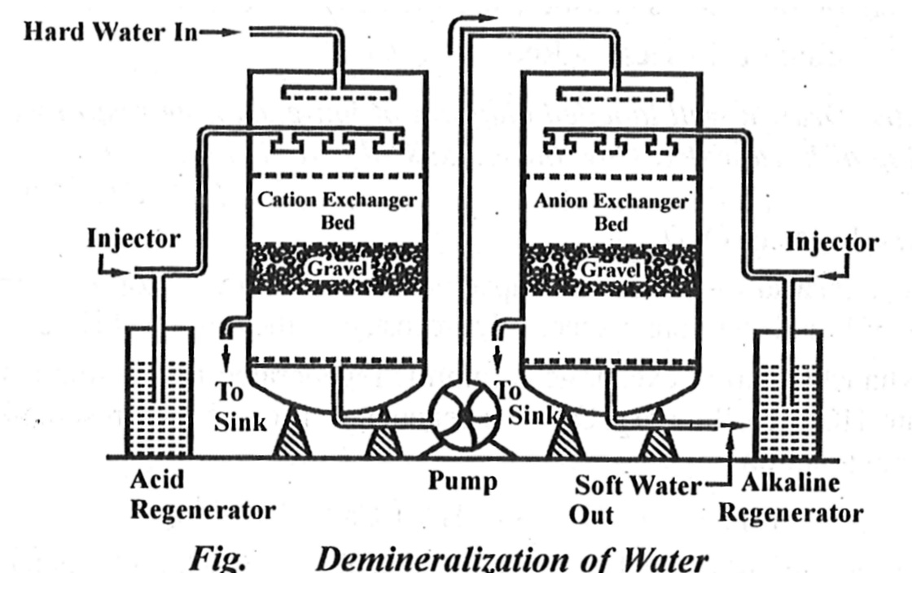

Resins containing acidic functional groups (-COOH, -SO3H etc.) are capable of exchanging their H+ ions with other cations, which come into their contact; whereas those containing basic functional groups (-NH2=NH as hydrochloric acid) are capable of exchanging their anions with other anions, which come into their contact.

The ion-exchange resins may be classified as: (i) Cation exchange resins (RH+ ) are mainly styrene-divinyl benzene copolymers, which on sulphonation or carboxylation become capable to exchange their hydrogen ions with the cations present in the raw water

1. Anion exchange resins (R1OH- ) are styrene-divinyl benzene amineformaldehyde copolymers, which contains amino or quaternary ammonium or quaternary phosphonium or tertiary sulphonium groups as an integral part of the resin matrixs. These, after treatment with dil. NaOH solution, become capable to exchange their OHanions with anions present in the raw water.

Process: The hard water is passed first through cation exchange column, which removes all the cations like Ca2+ or Mg2+, etc., from it and an equivalent amount of H+ ions are released from this column to water. Thus:

2RH + + Ca2+ →R2Ca 2+ + 2H +

2RH + + Mg 2+ →R2Mg 2+ + 2H +

The water which is now free from cations, is passed through anion exchange column, which removes all the anions like SO4 2- , Cl- etc., present in the water and equivalent amount OH- ions are released from this column to water. Thus:

R'OH - + Cl-→R'Cl + OH –

2R'OH - + SO42-→R'2 SO42- + 2OH –

2R'OH - + CO32-→R'2 CO32- + 2OH -

H + and OH-ions (released from cation exchange and anion exchange columns respectively) combine to produce water.

H + + OH - → H2O

Thus the water coming out from the exchanger is free from all cations as well as anions. Ion-free water is known as deionised or demineralised water.

Regeneration: When capacities of cation and anion exchangers to exchange H+ and OH ions respectively are lost, they are then said to be exhausted

The exhausted cation exchange column is regenerated by passing a solution of dil. HCl or H2SO4. The regeneration can be represented as:

R2Ca 2+ + 2H + → 2RH + + Ca2+ (Washing)

The column is washed with deionized water and such washing (which containing Ca2+, Mg2+, etc. and cation SO42- ) is passed into sink or drain. The exhausted anion exchange column is regenerated by passing a solution of dil. NaOH. The regeneration can be represented as:

R' 2 SO4 2- + 2OH - → 2R'OH - + SO42- (Washing)

###### Advantages

(1) The process can be used to soften highly acidic or alkaline waters.

(2) It produces water of very low hardness (2 ppm) .

###### Disadvantages

1. The equipment is costly and expensive chemicals are needed.
2. If water contains turbidity, then the output of the process is reduced.
3. The turbidity must be below 10 ppm. If it is more, it has to be removed first by coagulation followed by filtration.

Potable Water & Desalination of Brackish water is deleted from portion

###### Potable water

The water which is fit for human consumption is known as potable water

Municipalities have to supply potable water, i.e., water which is safe to human consumption should satisfy the following essential requirements

1. It should be sparkling clear and odourless.
2. It should be pleasant in taste
3. It should be perfectly cool
4. Its turbidity should not exceed 10 ppm
5. It should be free from objectionable dissolved gases like hydrogen sulphide.
6. It should be free from objectionable minerals such as lead, arsenic, chromium and manganese salts.
7. Its alkalinity should not be high. Its pH should not be above 8.0
8. It should be reasonably soft
9. Its total dissolved solids should be less than 500 ppm
10. It should be free from disease- producing micro- organisms.

###### Desalination of brackish water

The process of removing common salt (NaCl) from the water is known as desalination. Water containing high concentration of dissolved salts with a peculiar salty taste is called brackish water. Sea water is an example containing 3.5% of dissolved salts. The common methods for the desalination of brackish water are;

1. Electrodialysis
2. Reverse Osmosis

###### Eletctrodialysis: Electrodialysis (ED) is used to desalinate or concentrate a liquid process stream containing salts. ED is a highly efficient method for separating and concentrating salts. Electro Dialysis (ED) is a membrane process, during which ions are transported through semi permeable membrane, under the influence of an electric potential. The membranes are cation- or anion- selective, which basically means that either positive ions or negative ions will flow through Cation-selective membranes (polyelectrolytes with negatively charged matter) which rejects negatively charged ions and allows positively charged ions to flow through. By placing multiple membranes in a row, which alternately allow positively or negatively charged ions to flow through, the ions can be removed from saline water. In some columns concentration of ions will take place and in other columns ions will be removed. The concentrated saltwater flow is circulated until it has reached a value that enables precipitation. At this point the flow is discharged. This technique can be applied to remove ions from water. Cation-selective membranes consist of sulphonated polystyrene, while anion-selective membranes consist of polystyrene with quaternary ammonia. Sometimes pre-treatment is necessary before the electro dialysis can take place. Suspended solids with a diameter that exceeds 10 µm need to be removed, or else they will plug the membrane pores.

###### Image result for electrodialysis diagram

###### Reverse osmosis:

Osmosis is a natural phenomenon which can be defined as the movement of pure solvent through a semi permeable membrane from a low to a high concentration solution. The membrane is permeable to water and some ions but rejects almost all ions and dissolved solids. This process (movement of water) occurs until the osmotic equilibrium is reached, or until the chemical potential is equal on both sides of the membrane.

Reverse osmosis is a process which occurs when pressure, greater than the osmotic pressure, is applied to the concentrated solution. When two solutions of unequal concentrations are separated by a semi permeable membrane, flow of solvent takes place from dilute to concentrate sides, due to osmosis. If, however a hydrostatic pressure in excess to osmotic pressure is applied on the concentrated side, the solvent flow is reversed, i.e, solvent is forced to move from concentrated side to dilute side across the membrane. This is the principle of reverse osmosis (RO). Thus in reverse osmosis method, pure solvent is separated from its contaminants, rather than removing contaminants from the water.

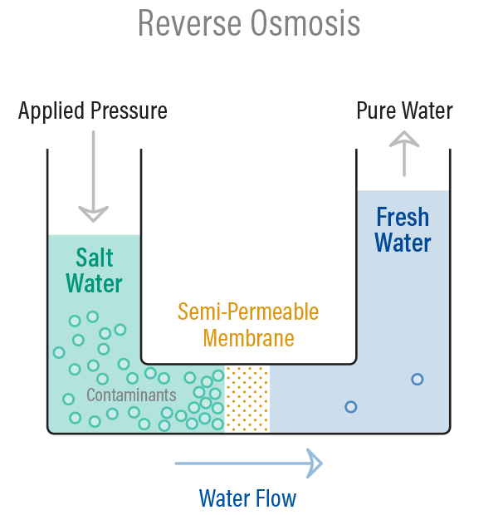

ADVANTAGES

1. Reverse osmosis possesses distinct advantages of removing ionic as well as non-ionic, colloidal and high molecular weight organic matter.
2. The maintenance cost is almost entirely on the replacement of the semi permeable membrane.
3. The life time of membrane is quite high, about 2 years,
4. The membrane can be replaced within a few minutes, thereby providing nearly uninterrupted water supply.
5. It has low capital cost, simplicity, low operating cost and high reliabile.

**Methods to Determine extent of water pollution:**

* 1. **Biological Oxygen Demand (BOD)**
  2. **Chemical Oxygen Demand (COD)**

Biological Oxygen Demand: (BOD)

**Biochemical oxygen demand** (**BOD**) is the amount of dissolved oxygen needed (i.e. demanded) by aerobic biological organisms to break down organic material present in a given water sample at certain temperature over a specific time period. The BOD value is most commonly expressed in milligrams of oxygen consumed per litre of sample during 5 days of incubation at 20 °C

Determination of BOD:

1. Specialized 300 mL BOD bottles designed to allow full filling with no air space and provide an airtight seal are used. The bottles are filled with the sample to be tested or dilution (distilled or deionized) water and various amounts of the wastewater sample are added to reflect different dilutions. At least one bottle is filled only with dilution water as a control or "blank."
2. A DO meter is used to measure the initial dissolved oxygen concentration (mg/L) in each bottle, which should be a least 8.0 mg/L. Each bottle in then placed into a dark incubator at 20°C for five days.
3. After five days (± 3 hours) the DO meter is used again to measure a final dissolved oxygen concentration (mg/L), which ideally will be a reduction of at least 4.0 mg/L.
4. The final DO reading is then subtracted from the initial DO reading and the result is the BOD concentration (mg/L). If the wastewater sample required dilution, the BOD concentration reading is multiplied by the dilution factor.

BOD = (Dob –DO5) x dilution factor

= (Dob –DO5) x Volume of diluted sample

Volume of effluent sample

Significance of BOD:

Biochemical oxygen demand / biological oxygen demand is an important water quality parameter because it provides an index to assess the effect discharged wastewater will have on the receiving environment.  The BOD is important in sewage treatment because it indicates the amount of decomposable organic matter in sewage water. The higher the value of BOD higher will be decomposable organic matter present in wastewater.

Chemical Oxygen Demand:

The chemical oxygen demand (COD) is a measure of water and wastewater quality. The COD test is often used to monitor water treatment plant efficiency. The COD is the amount of oxygen consumed to chemically oxidize organic water contaminants to inorganic end products. The COD is often measured using a strong oxidant (e.g. potassium dichromate) under acidic conditions.

* A known volume of waste water sample (say 250 ml) is refluxed with a known excess of standard potassium dichromate (1 N) and dilute sulfuric acid mixture in the presence of silver sulphate catalyst for about 3 hours.
* This oxidases organic matter to CO2, NH3 and H2O.
* The unreacted potassium dichromate is titrated against Ferrous ammonium sulphate (Mohr’s salt) with ferroin indicator till blue colour changes to wine red, the reading is **(Vt).**
* This gives the amount of potassium dichromate consumed (in terms of equivalent oxygen) required for degradation of organic pollutants.

Blank titration is performed initially with known volume of distilled water sample and added acidified standard potassium dichromate titrated against Ferrous ammonium sulphate (Mohr’s salt) with ferroin indicator till blue colour changes to wine red, the reading is **(Vb)** (zero minute reading)

Measurement of COD:

Blank Titration:

H2SO4

Distilled water + K2Cr2O7---------🡪 D.W + K2Cr2O7

Excess HgSO4 Total

* Sample Titration:

H2SO4

Waste water + K2Cr2O7---------🡪 CO2 + H2O + K2Cr2O7

Excess HgSO4 Unreacted Formula:

COD = (Vb –Vs) x NFAS x 8000

Volume of sample

Where,

Vb : Volume of FAS for blank titration

Vs : Volume of FAS for sample titration

Significance of COD:

* The COD test only takes a few hours to complete, giving it a major advantage over the 5-day BOD test. Wastewater treatment system personnel can use COD as an almost real-time operational adjustment parameter.
* COD can test wastewater that is too toxic for the BOD test.
* The COD test should be considered an independent measure of the organic matter in a wastewater sample rather than a substitute for the BOD test.
* The COD test uses a chemical (potassium dichromate in a 50% sulfuric acid solution) that “oxidizes” both organic (predominate) and inorganic substances in a wastewater sample, which results in a higher COD concentration than BOD concentration for the same wastewater sample since only organic compounds are consumed during BOD testing.

|  |  |
| --- | --- |
| BOD | COD |
| 1. It is oxygen required or demanded by micro-organism for aerobic oxidation of organic matter present in waste water. | 1. It is oxygen required or demanded for oxidation of organic as well as inorganic matter present in waste water using strong chemical oxidant like K2Cr2O7 |
| 2. It uses microorganism for degradation | 2. It uses chemical oxidant for degradation |
| 3. It is slow process require 5 days’ time | 3. It is fast process require only few hours |
| 4. Pollutants are not break down completely only | 4. Pollutants are oxidizes completely. |
| 5. organic matter oxidizes by micro organism | 5. Both organic and inorganic matter oxidizes by chemical oxidant |
| 6. BOD values are generally lower than that of COD | 6. COD values are generally higher than that of BOD |
|  |  |

**Treatment of sewage / Industrial waste:**

In activated sludge process wastewater containing organic matter is aerated in an aeration basin in which micro-organisms metabolize the suspended and soluble organic matter. In activated sludge systems a part of this settled biomass, described as activated sludge is returned to the aeration tank and the remaining forms waste or excess sludge. In activated sludge process wastewater containing organic matter is aerated in an aeration basin in which micro-organisms metabolize the suspended and soluble organic matter. A part of this settled biomass, described as activated sludge is returned to the aeration tank and the remaining forms waste or excess sludge.

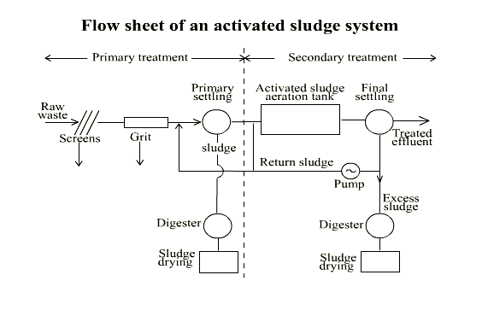

**Step 1: Screening and Pumping**

The incoming wastewater passes through screening equipment where objects such as rags, wood fragments, plastics, and grease are removed. The material removed is washed and pressed and disposed of in a landfill. The screened wastewater is then pumped to the next step: grit removal.

**Step 2: Grit Removal**In this step, heavy but fine material such as sand and gravel is removed from the wastewater. This material is also disposed of in a landfill.

**Step 3: Primary Settling**The material, which will settle, but at a slower rate than step two, is taken out using large circular tanks called clarifiers. The settled material, called primary sludge, is pumped off the bottom and the wastewater exits the tank from the top. Floating debris such as grease is skimmed off the top and sent with the settled material to digesters. In this step, chemicals are also added to remove phosphorus.

**Step 4: Aeration / Activated Sludge**In this step, the wastewater receives most of its treatment. Through biological degradation, the pollutants are consumed by microorganisms and transformed into cell tissue, water, and nitrogen. The biological activity occurring in this step is very similar to what occurs at the bottom of lakes and rivers, but in these areas the degradation takes years to accomplish.

**Step 5: Secondary Settling**Large circular tanks called secondary clarifiers allow the treated wastewater to separate from the activated sludge from the aeration tanks at this step, yielding an effluent, which is now over 90% treated. The biology (activated sludge) is continuously pumped from the bottom of the clarifiers and returned to the aeration tanks in step four.

**Step 6: Disinfection**To assure the treated wastewater is virtually free of bacteria, ultraviolet disinfection is used after the filtration step. The ultraviolet treatment process kills remaining bacteria to levels within our discharge permit.